**AIR QUALITY ASSESSMENT-TAMIL NADU**

**TEAM MEMBER**

**962221106075 : Mohammad Roshan**

**Phase-1 Document Submission**

**Project: AIR QUALITY ASSESSMENT**

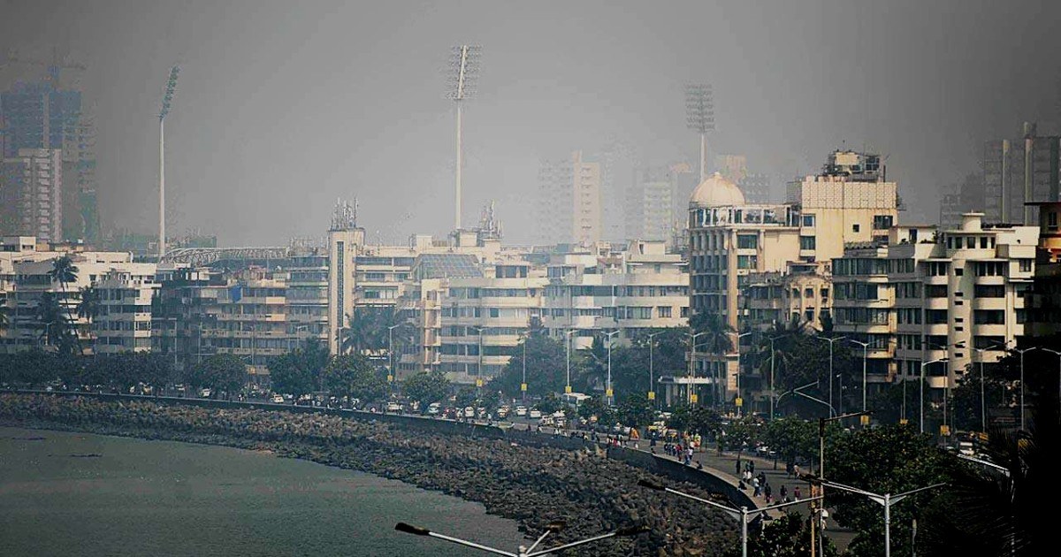

**OBJECTIVE :** The project aims to analyze and visualize air quality data from monitoring stations in Tamil Nadu. The Objective is to gain insights into air pollution trends, identify areas with high pollution levels, and develop a predictive model to estimate RSPM/PM10 levels based on SO2 and NO2 levels. This project involves Defining objectives, designing the analysis approach, selecting visualized techniques, and creating a Predictive model using Python and relevant libraries. Air Quality Analysis Objectives.

**PHASE -1 : Problem definition and Design thinking**

**Dataset Link :** [**https://tn.data.gov.in/resource/location-wise-daily-ambient-air-quality-tamil-nadu-year-2014**](https://tn.data.gov.in/resource/location-wise-daily-ambient-air-quality-tamil-nadu-year-2014)

1. Air Quality Trends: This objective involves studying historical data on air quality parameters, such as pollutant levels, meteorological conditions, and emission sources, to understand how air quality has changed over time. This analysis helps identify long-term trends, seasonal variations, and potential contributing factors.
2. Identifying Pollution Hotspots: This objective focuses on pinpointing specific geographic areas or locations where air pollution levels consistently exceed acceptable limits. By identifying pollution hotspots, authorities can prioritize targeted interventions and regulatory measures to reduce pollution in these areas.

1. Building a Predictive Model for RSPM/PM10 Levels: This objective involves developing a statistical or machine learning model that can forecast levels of Respirable Suspended Particulate Matter (RSPM) or Particulate Matter with a diameter of 10 micrometers or less (PM10). This model typically uses historical data, meteorological information, and other relevant variables to make predictions, aiding in proactive pollution management and public health planning.

These objectives collectively contribute to better air quality management and the protection of public environment.

**ANALYSIS APPROACH:**

**Steps to load, preprocess, analyze, and visualize the air quality data:**

Certainly! Here are the steps to load, preprocess, analyze, and visualize air quality data:

1. Load Data:

✓Obtain the air quality data from reliable sources, which may include government agencies, environmental organizations, or research institutions.

✓The data may be available in various formats like CSV, Excel, or specialized formats like JSON or XML.

2. Preprocess Data:

✓Data Cleaning :

Handle missing values: Replace or interpolate missing data points if possible, or consider removing incomplete records. Check for outliers and anomalies: Identify and address any data points that deviate significantly from the rest of the dataset.

✓Data Transformation:

Convert data types: Ensure that variables are in the correct data type (e.g., numerical, categorical, date).Normalize or standardize data if necessary to bring it to a consistent scale.

✓Feature Engineering:

Create new features that might be useful for analysis (e.g., derived variables, aggregates).Encode categorical variables using techniques like one-hot encoding.

3.Data Analysis:

✓Descriptive Statistics:

Calculate basic statistics like mean, median, standard deviation, and percentiles to understand the distribution of the data.

✓Time Series Analysis (if applicable):

Explore temporal patterns, trends, and seasonality using techniques like moving averages, decomposition, or autocorrelation.

✓Correlation Analysis:

Identify relationships between different variables, especially pollutants, meteorological conditions, and geographical features.

✓Spatial Analysis (if applicable):

Use GIS tools or libraries to analyze spatial patterns and relationships.

4.Build Predictive Models (Optional):

✓If you plan to build predictive models, split the data into training and testing sets.

✓Select an appropriate modeling technique (e.g., regression, time series forecasting, machine learning algorithms) and train the model.

**Air Quality Monitoring :**

With the increased industrial and commercial activities in the vicinity of major cities, the quality of the ambient air is being affected by emissions from the industries and from the ever increasing vehicular population. As per the provision of Air (Prevention and Control of Pollution) Act, 1981, the entire state of Tamil Nadu has been declared as an air pollution control area.

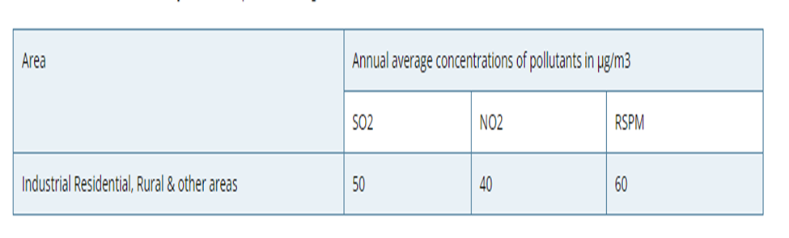

**VIRTUALIZTION ANALYSIS:**

✓Time Series Plots:

Plot air quality parameters over time to visualize trends, seasonal variations, and anomalies. ✓Histograms and Box Plots:

Display the distribution of pollutant levels and other relevant variables.

✓Scatter Plots (for correlation analysis):

Visualize relationships between different variables.

✓Geospatial Visualization (if applicable):

Create maps to show spatial distribution of air quality data and pollution hotspots

**ANALYSIS APPROACH :**

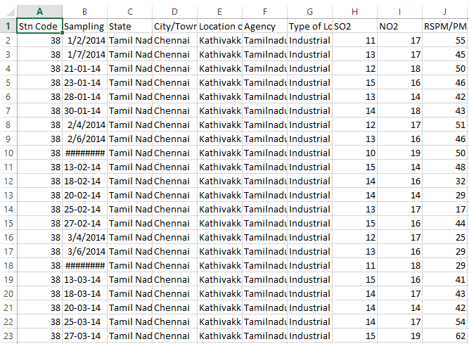

<?xml

version="1.0"?>

<DATASET>

<ROW1>

<STN_CODE>38

</STN_CODE>

<SAMPLING_DATE>010214

</SAMPLING_DATE>

<STATE>Tamil Nadu

</STATE>

<CITYTOWNVILLAGEAREA>Chennai

</CITYTOWNVILLAGEAREA>

<LOCATION_OF_MONITORING_STATION>Kathivakkam Municipal Kalyana Mandapam Chennai

</LOCATION_OF_MONITORING_STATION>

<AGENCY>Tamilnadu State Pollution Control Board

</AGENCY>

<TYPE_OF_LOCATION>Industrial Area

</TYPE_OF_LOCATION>

<SO2>11

</SO2>

<NO2>17

</NO2>

<RSPMPM10>55

</RSPMPM10>

<PM_2.5>NA

</PM_2.5>

</ROW1>

<ROW2>

<STN_CODE>38

</STN_CODE>

<SAMPLING_DATE>010714

</SAMPLING_DATE>

<STATE>Tamil Nadu

</STATE>

<CITYTOWNVILLAGEAREA>Chennai

</CITYTOWNVILLAGEAREA>

<LOCATION_OF_MONITORING_STATION>Kathivakkam Municipal Kalyana Mandapam Chenna

i</LOCATION_OF_MONITORING_STATION>

<AGENCY>Tamilnadu State Pollution Control Board

</AGENCY>

<TYPE_OF_LOCATION>Industrial Area

</TYPE_OF_LOCATION>

<SO2>13

</SO2>

<NO2>17

</NO2>

<RSPMPM10>45

</RSPMPM10>

<PM_2.5>NA

</PM_2.5>

</ROW2>

**CONCLUSION :**

**In phase 1,we have established a understanding of our goal to predict the air quality of tamilnadu with the analysis approaches and visualizations.**